# Automatic Lighting (by Kishore kumar J)

## Circuit :

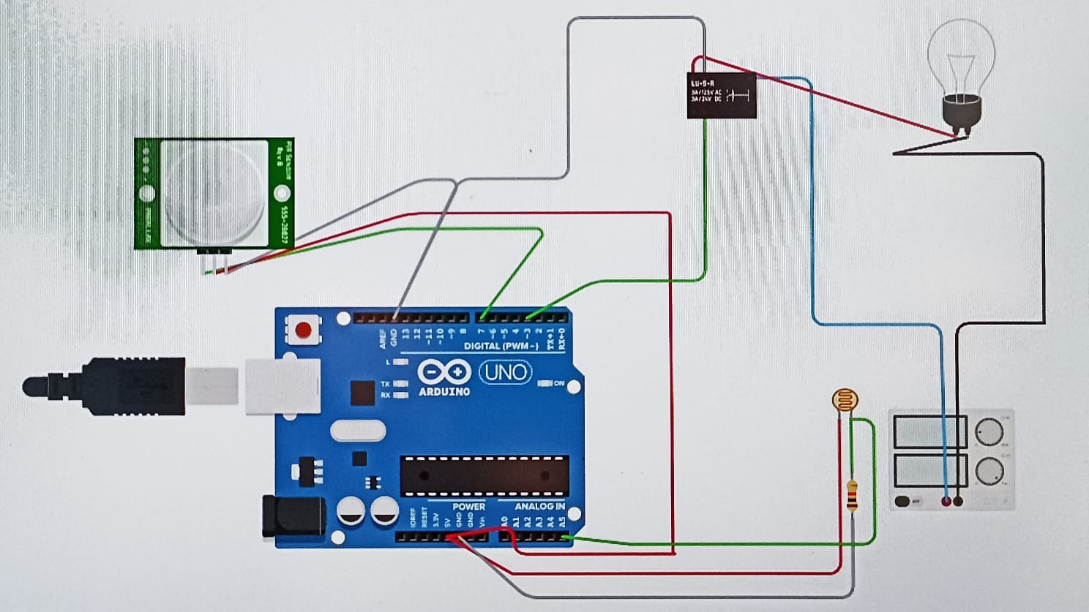

## Components Used :

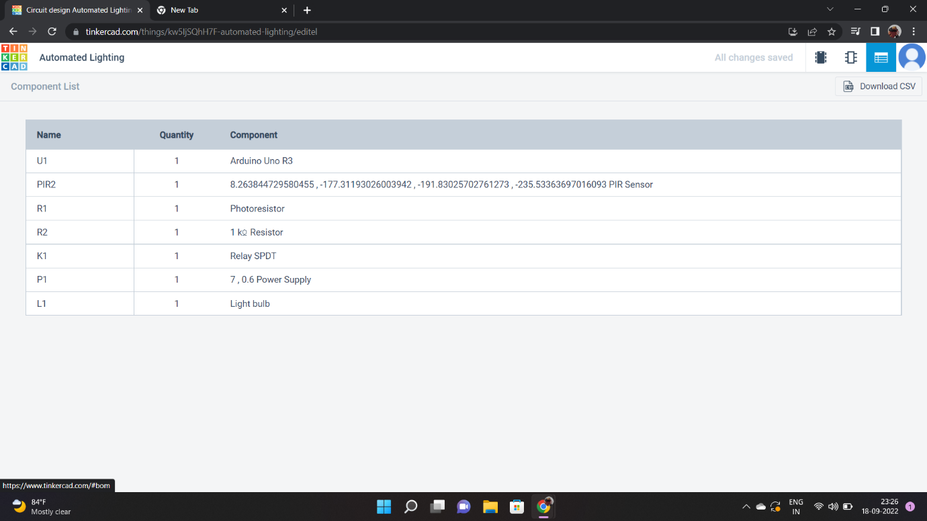

Project description :

Automated lighting system detects if anyone enters in the room (range of sensor used), the light bulb will glow.The intensity of light is adjusted automatically according to the brightness level present in the room already.

## Code :

int PIR ,PS;

void setup ()

{

pinMode( 7, INPUT);

pinMode( 3, OUTPUT);

pinMode( A5, INPUT);

Serial.begin(9600);

}

void loop ()

{

PIR= digitalRead(7);

PS= analogRead(A5);

Serial.println(PIR);

Serial.println(PS);

if ((PIR>0) && (PS<550))

{

analogWrite(3,map(PS,549,6,0,255));

delay(5000);

}

else

digitalWrite(3, 0);

}

## Designed by ,

Name:Kishore kumar J

Reg no : 113119UG04050

College: Veltech multitech college of engineering